Nantha Kumar and Pankaj Kumar
- Project Name: Test Freshers
- KT Delivered By: Janmejay
- KT Link:https://meet.google.com/hmg-dpph-yoa
Monday 29th September - 9:00 PM

Topbrains
This application is for trainer and student
->take classes online
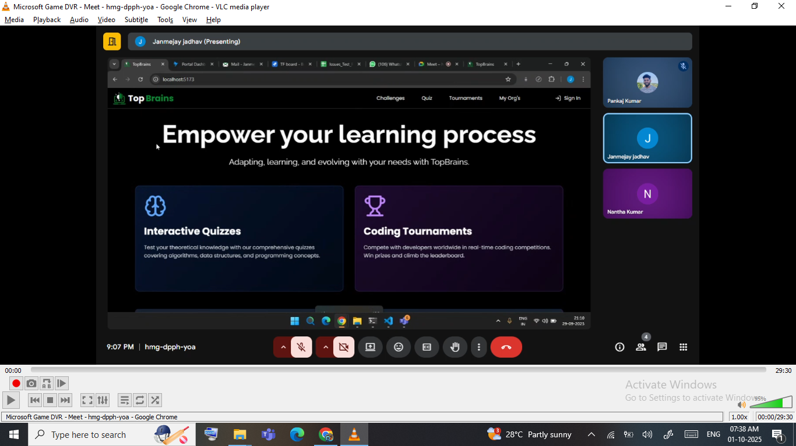

This application has 10 Modules (10 roles)
It Starts with

SL.NO |  | LOWER LEVEL | EXTRA ROLE
1 | Super admin | Admin | Trainer
2 | Super Task Manager | Task Manager | Student (MAIN END USER OF APPLICATION)
3 | Super adder | Task Adder
4 | Super verifier | Task Verifier

